## **Detailed Notes on Convolutional Neural Networks (CNNs)**

<https://medium.com/thedeephub/convolutional-neural-networks-a-comprehensive-guide-5cc0b5eae175>

### **1. What are Convolutional Neural Networks (CNNs)?**

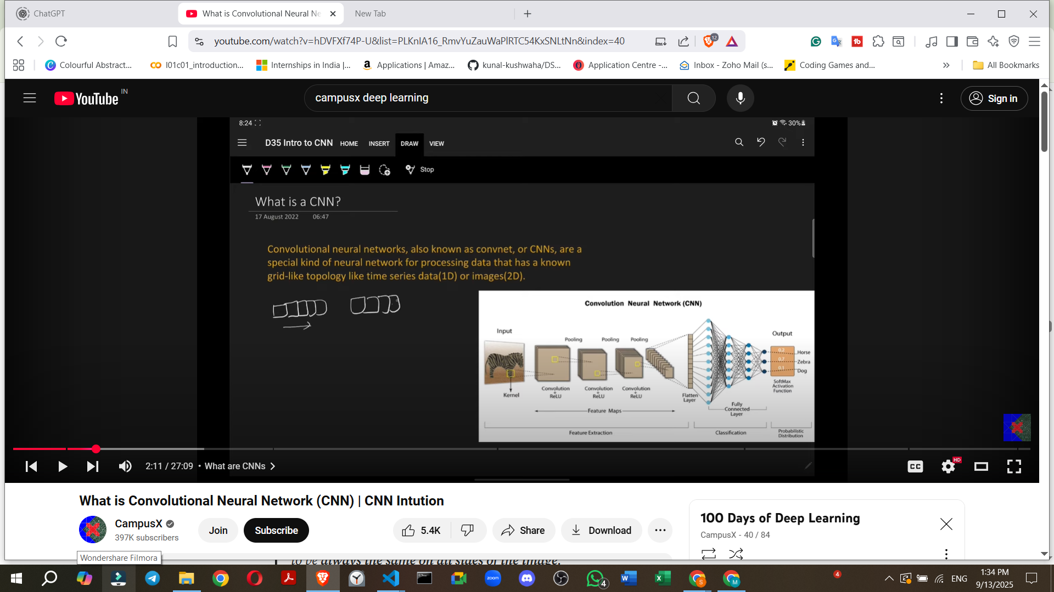

* **Definition**: Convolutional Neural Networks, also known as ConvNets or CNNs, are a special kind of neural network.
* **Purpose**: They are specifically designed for processing data that has an **unknown grid-like topology**.
* **Examples of Grid-like Data**:
  + **Time series data** (1D), where data arrives sequentially, one time step after another.
  + **Images** (2D), where pixels are arranged in a grid-like structure.

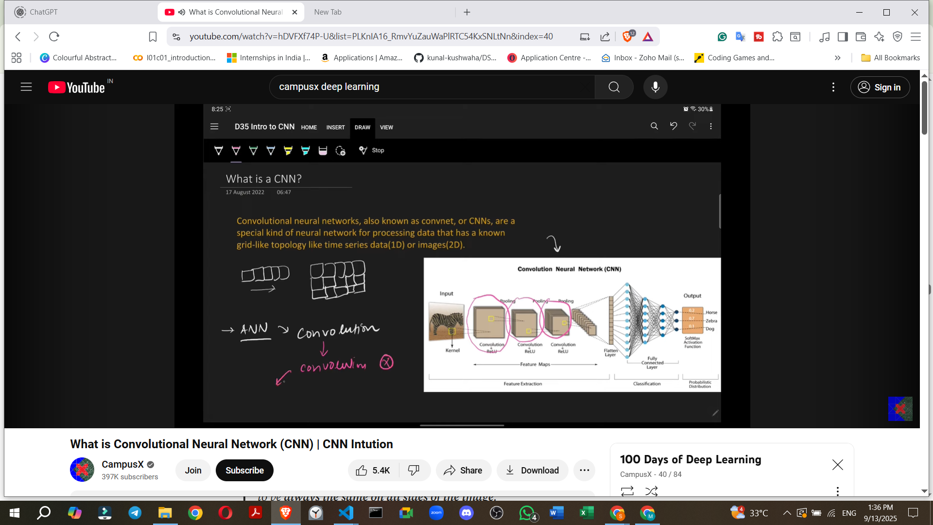

* **Primary Application**: CNNs are very widely used for **image classification data** and have a multitude of applications today. They are considered a very important topic to study.

### **2. Key Differences from Artificial Neural Networks (ANNs)**

* **Core Operation**: The main distinguishing feature of a CNN is the presence of **convolutional layers**. These layers perform a special operation called the **"convolution operation"**.
* **ANNs vs. CNNs**: In contrast, traditional ANNs use **matrix multiplication** for their operations.

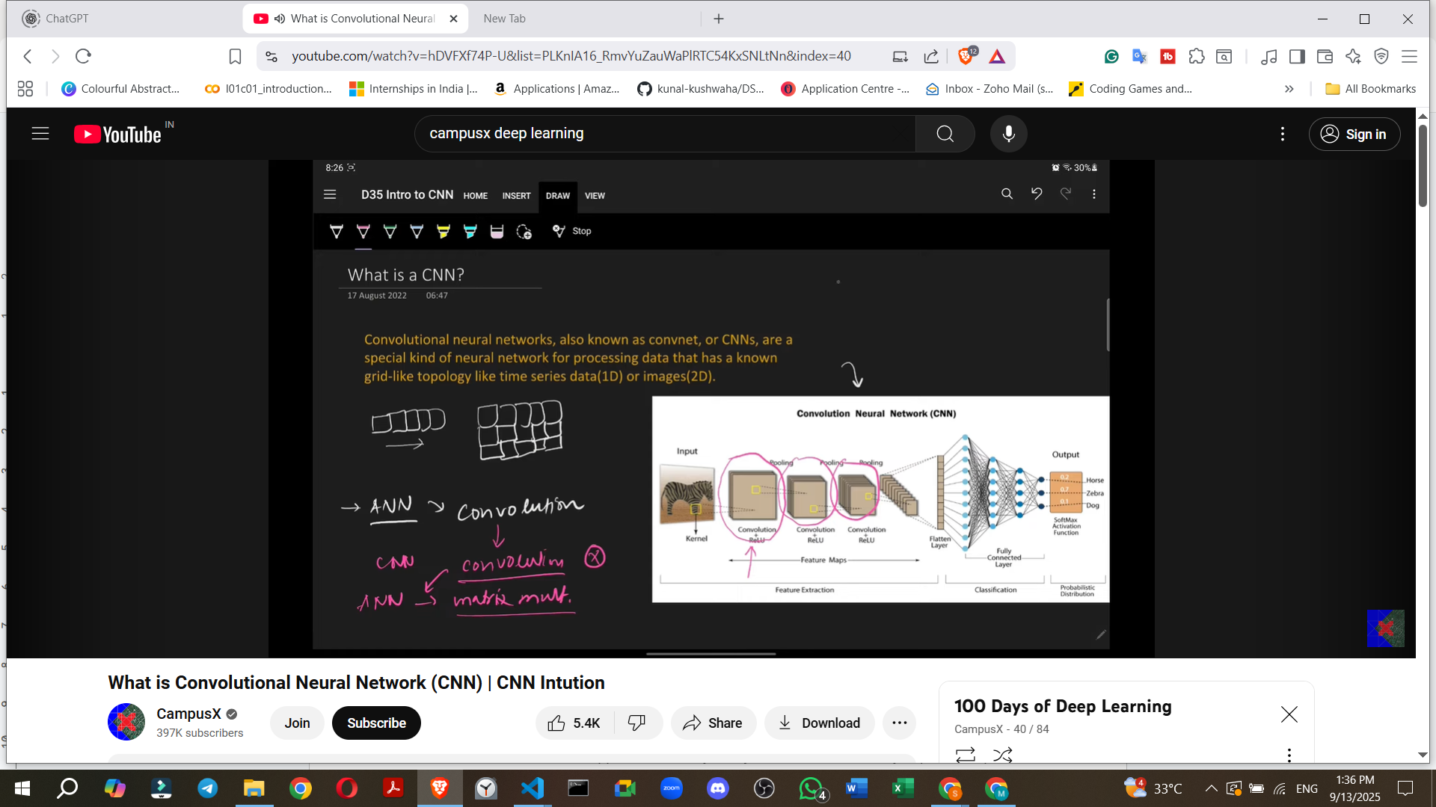

* **Identification**: If a neural network's architecture contains even a single convolutional layer, it is classified as a CNN.

### **3. Architecture and Components of a CNN**

A CNN typically consists of three main types of layers:

1. **Convolutional Layer**:
   * This is the primary layer that performs the **convolution operation**.
   * Its main function is to **extract features** from the input image.
2. **Pooling Layer**:
   * While not detailed in the introductory video, it is mentioned as a crucial component of a CNN architecture.
   * It is typically used to reduce the spatial dimensions (width and height) of the input volume for the next convolutional layer [Source did not specify its function beyond being a layer type].
3. **Fully Connected Layer (FCL)**:
   * This layer is similar to those found in ANNs, where every node (neuron) in the layer is connected to every node in the subsequent layer.
   * The FCL usually forms the final part of the CNN, used for classification based on the features extracted by the convolutional and pooling layers.

### **4. Inspiration and History**

* **Inspiration**: CNNs are heavily **inspired by the human brain's visual cortex** – the part of our brain responsible for sight. Computer scientists studied how the human brain processes visual information and transferred that understanding into the design of CNNs.
* 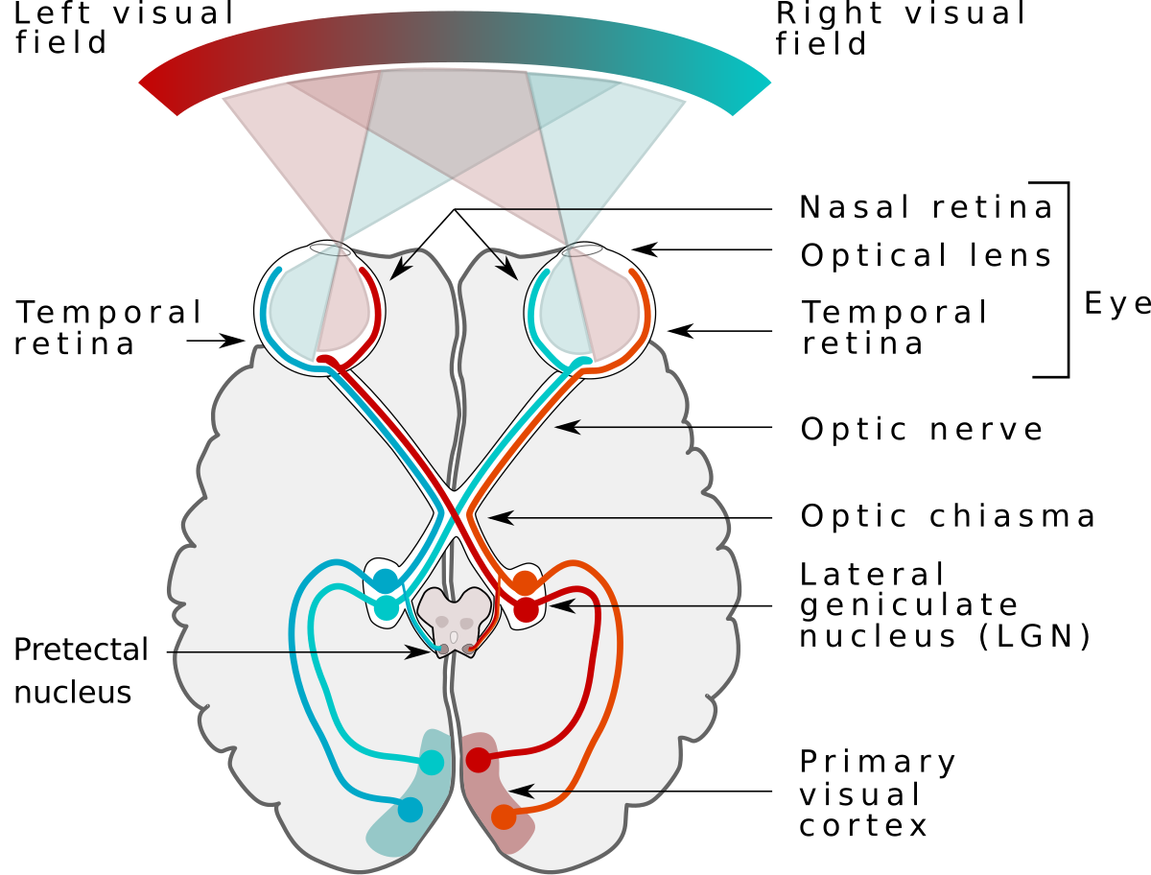
* **History**:
  + **1998**: **Yann LeCun** developed the first successful convolutional network at AT&T Labs.
  + **Application**: This early CNN was capable of scanning checks and **identifying handwritten digits**.
  + **Subsequent Developments**: Following this, Microsoft developed various OCR (Optical Character Recognition) and handwriting recognition tools, which significantly boosted research in CNNs.
  + **Modern Day**: Today, CNNs are one of the most popular and successful neural networks available. They are integral to applications ranging from **facial recognition software to self-driving cars**. Their impact on society is profound due to their successful real-world implementations.

### **5. Why CNNs are Necessary (Problems with ANNs on Image Data)**

While ANNs can be used for image classification (e.g., achieving about 98% accuracy on the MNIST handwritten digits dataset), CNNs consistently perform better. The primary reasons why ANNs are not ideal for image data are:

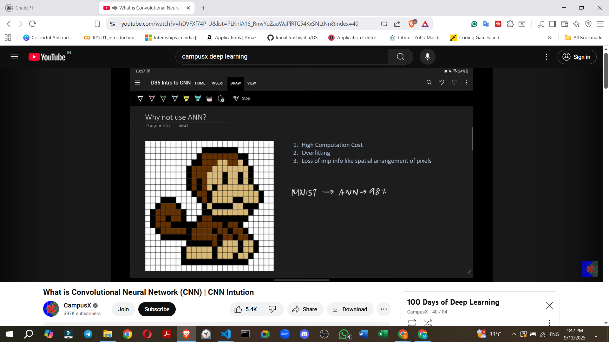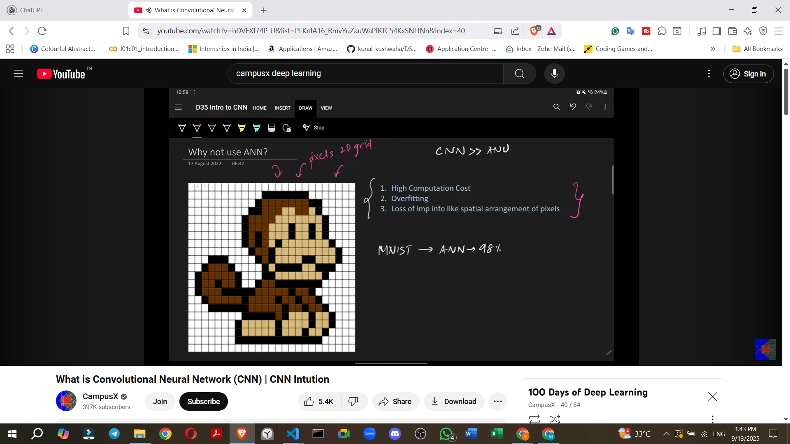

1. **High Computational Cost**:
   * **Image Structure**: An image is essentially a **2D grid of pixels**.
   * **ANN Input Requirement**: For an ANN, this 2D image must be **flattened into a 1D array** of numbers. For example, a 40x40 pixel image has 1600 pixels, which become 1600 numbers in a 1D array.
   * **Weight Explosion**: When these 1D pixels are connected to a fully connected hidden layer, the number of weights becomes extremely large.
     + **Example**: For a small 40x40 pixel image (1600 pixels) connected to a modest hidden layer with 100 units, the number of weights in just the first layer would be **1600 * 100 = 160,000 weights**.

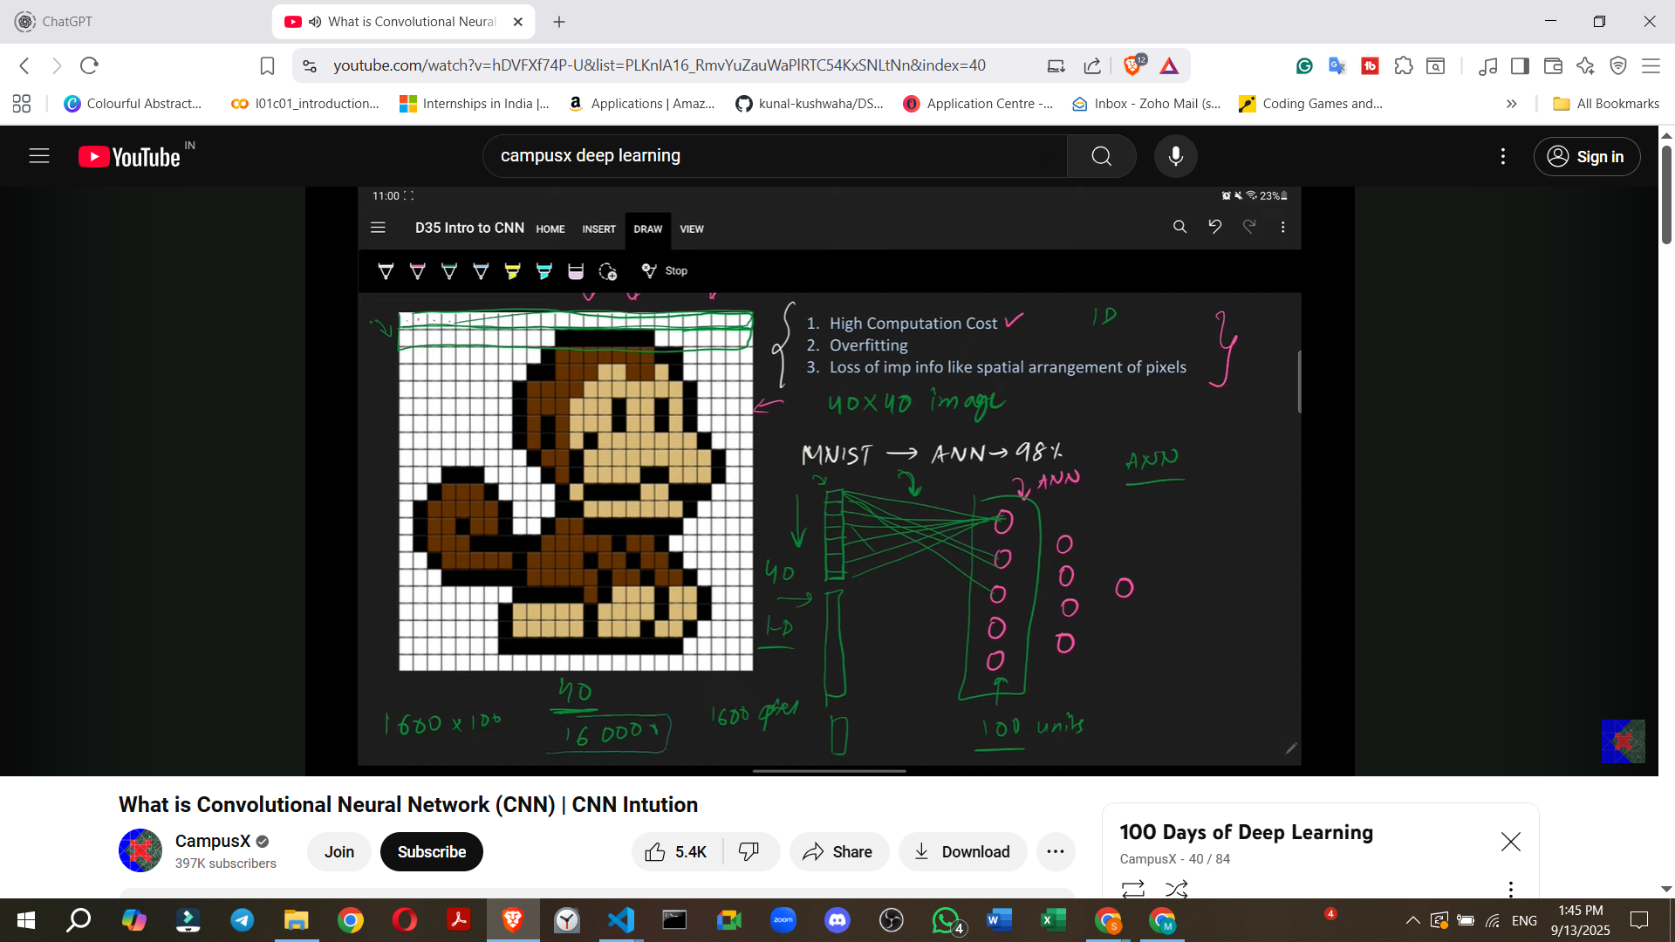

* + **Consequence**: As image sizes increase (e.g., 1000x1000 pixels) or the number of hidden units grows, the number of weights can reach millions or billions, leading to **immense computational costs** and significantly longer training times.

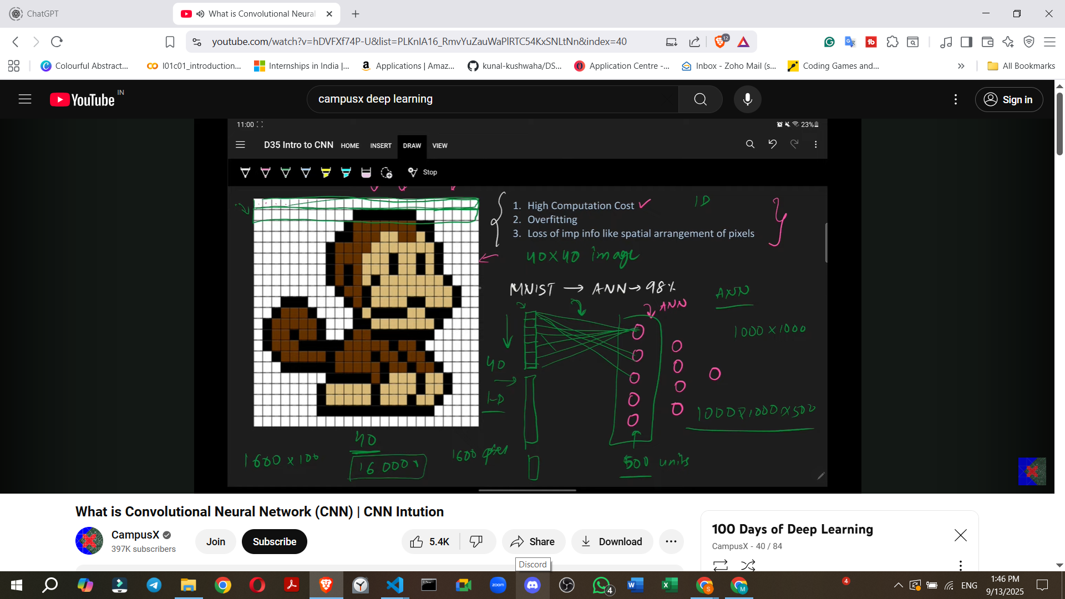

1. **Overfitting**:
   * By connecting every single pixel to every node in the subsequent layer, an ANN attempts to learn and capture every minute pattern in the image, no matter how insignificant.
   * **Consequence**: This exhaustive learning often leads to **overfitting**, where the model performs exceptionally well on the training data but fails to generalize and performs poorly on new, unseen test data.
2. **Loss of Spatial Arrangement**:
   * **Crucial Features**: The spatial arrangement and relationships between pixels (e.g., the distance and relative position of a monkey's eye and nose) are **very important features** for identifying objects in an image.

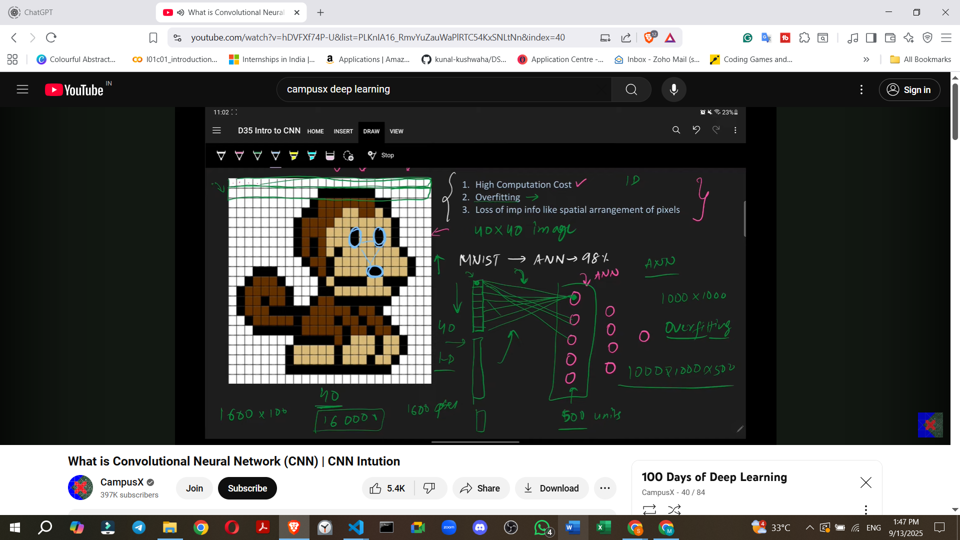

* + **Flattening Issue**: When a 2D image is converted into a 1D array for an ANN, this critical **spatial context and arrangement are completely lost**.
  + **Consequence**: The loss of these inherent 2D features severely hampers the ANN's ability to effectively classify images, leading to less accurate results compared to CNNs.

### **6. How CNNs Work: Intuition and Feature Extraction**

CNNs approach image classification by mimicking how the human brain identifies objects.

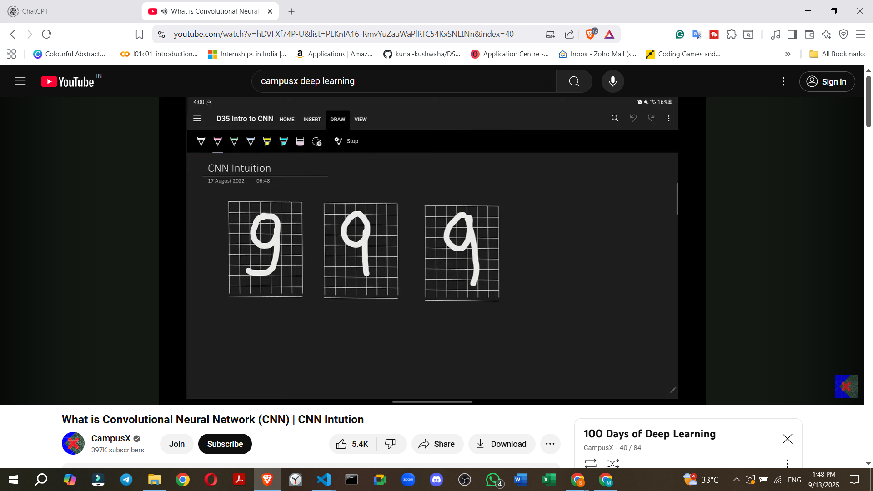

* **Human Brain Analogy**:
  + Consider classifying the digit '9'. Our brain doesn't just see a whole '9'; it looks for specific patterns: a **circle**, a **vertical line**, and a **horizontal line**.

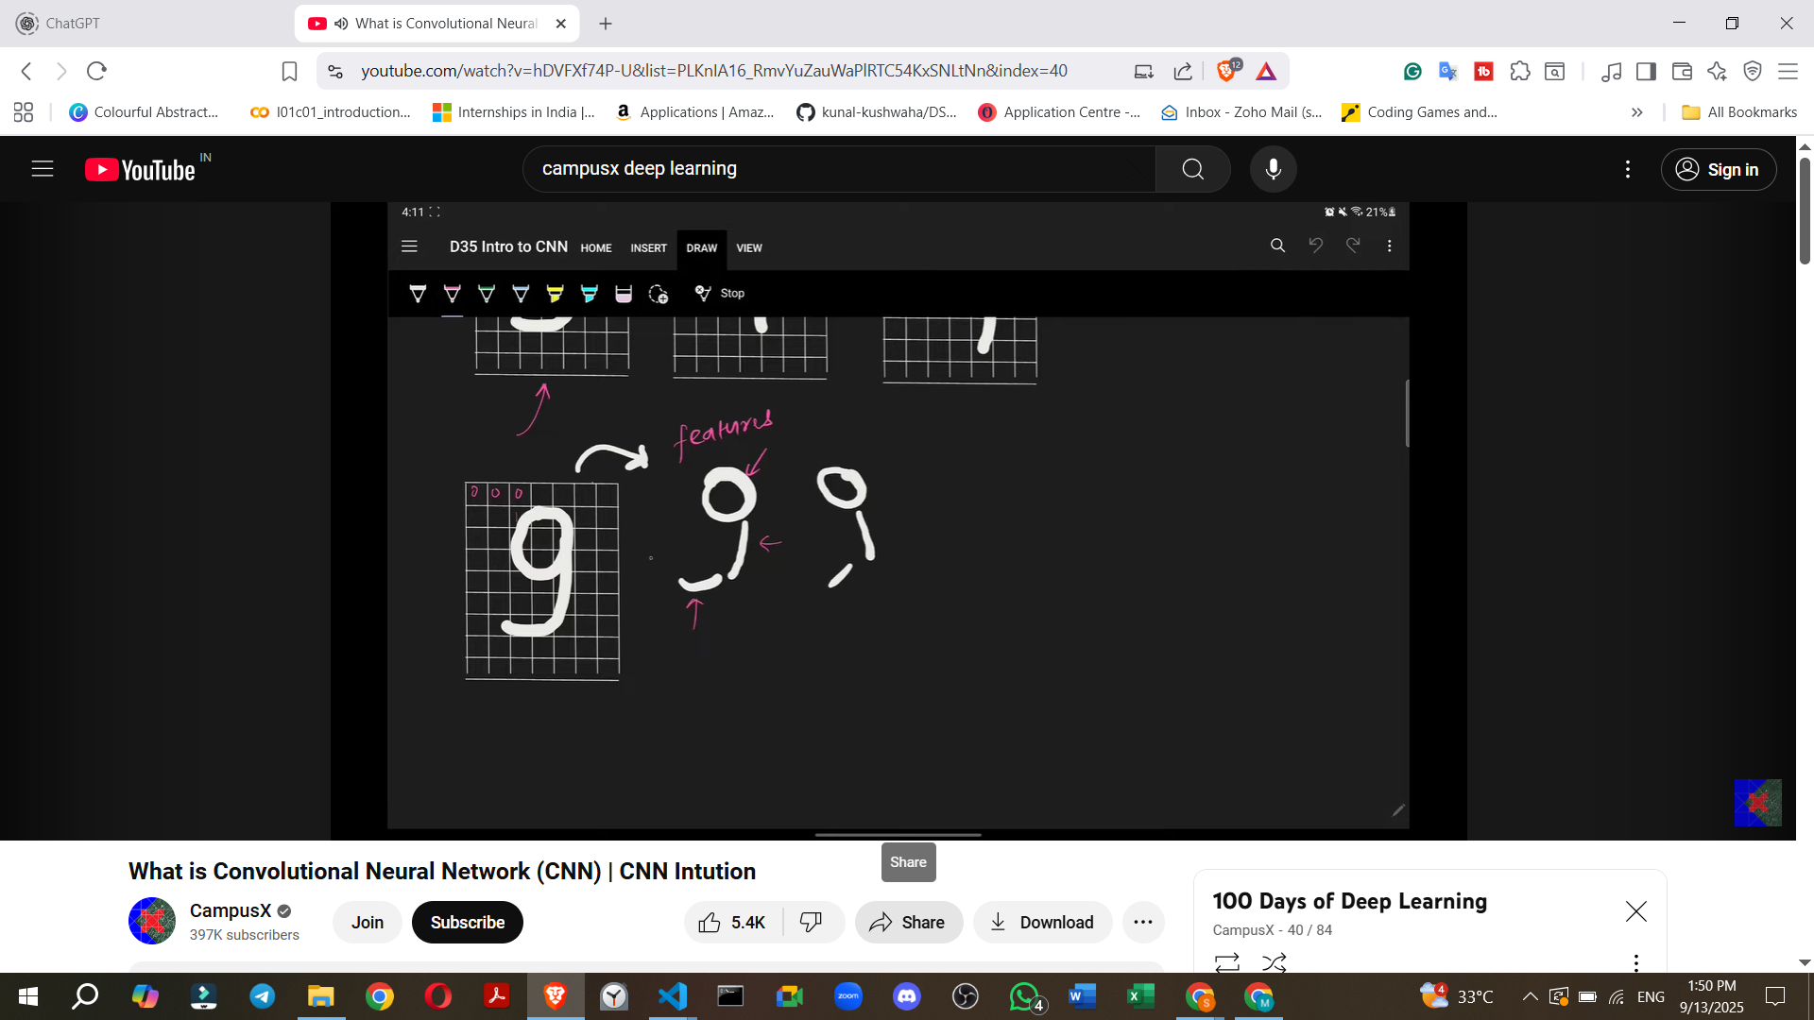

* + Even if these patterns are slightly distorted (e.g., a slightly imperfect circle or angled lines), our brain can still recognize the '9'.
  + This process involves **breaking down the digit into its component features**.
* **CNN Mechanism**:
  + **Primitive Feature Extraction**: When a CNN receives an image, its initial convolutional layers focus on extracting **primitive features** such as **edges** (horizontal, vertical, diagonal lines, corners).

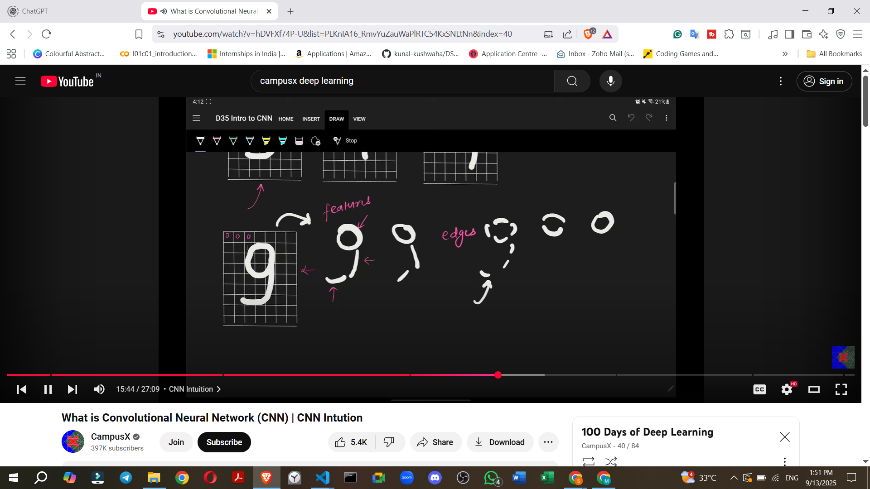

* + - **Example**: For a '9', the CNN first identifies the basic edges that form the circle, the vertical stem, and the horizontal base.

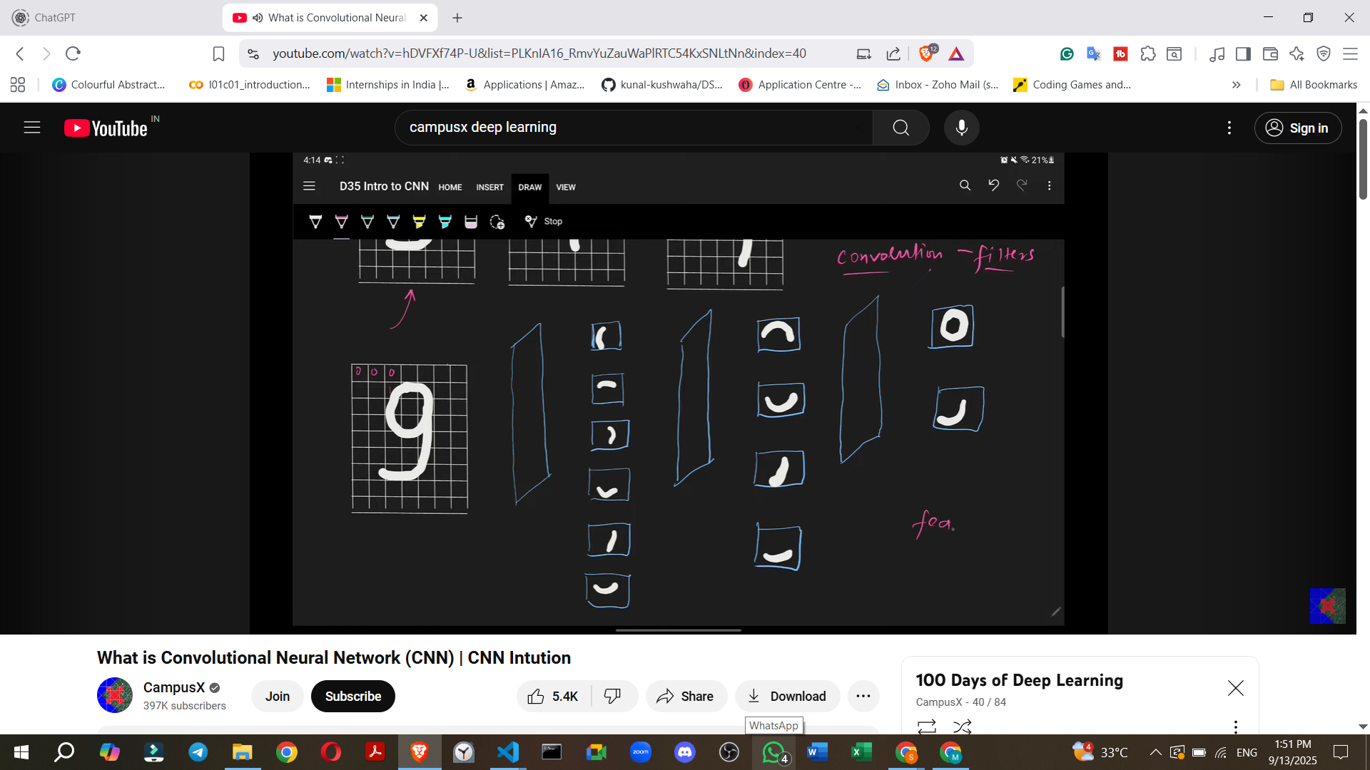

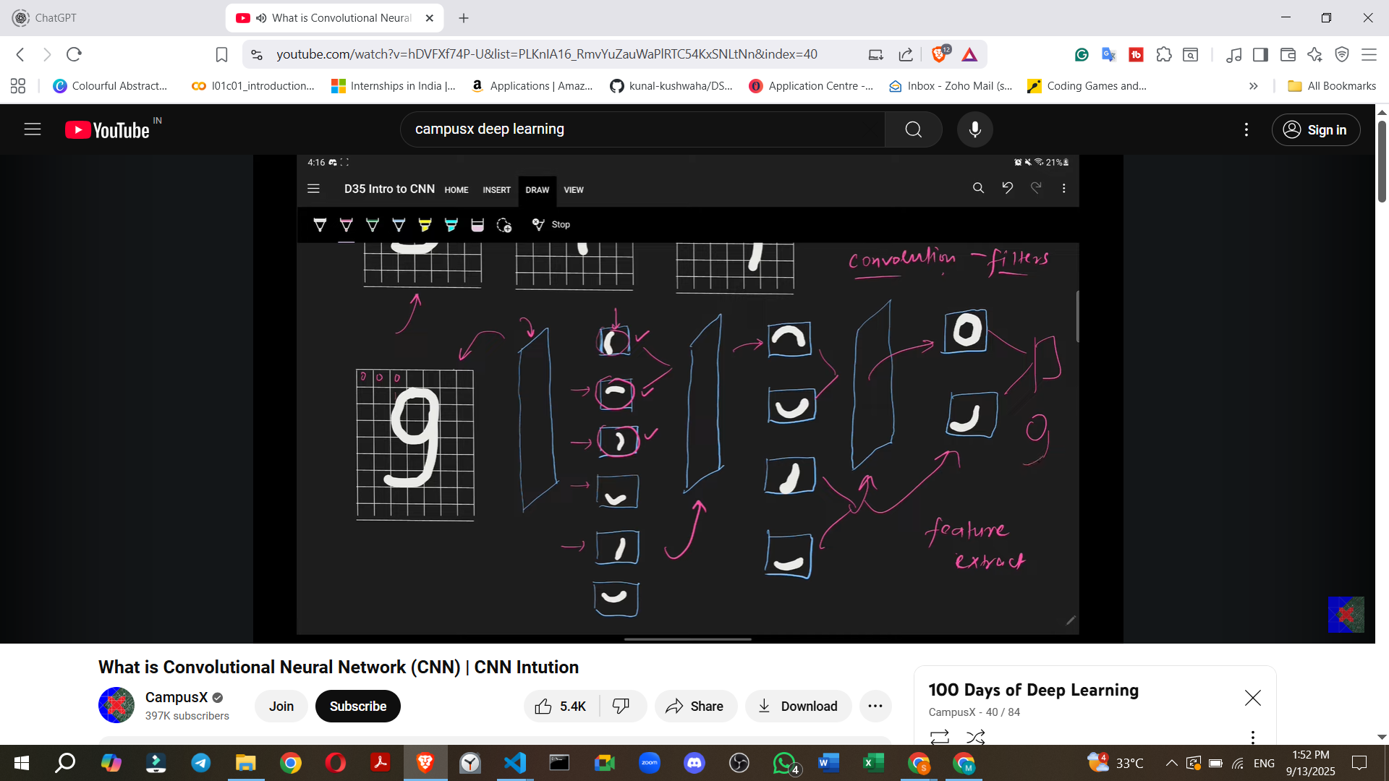

* + **Filters/Kernels**: Convolutional layers employ **"filters"** (also known as kernels). These are small matrices that "slide" or "move" across the input image.
    - The purpose of these filters is to **detect specific patterns or features** within the image.
    - When a filter matches a particular pattern (e.g., a vertical edge), that feature becomes "activated".

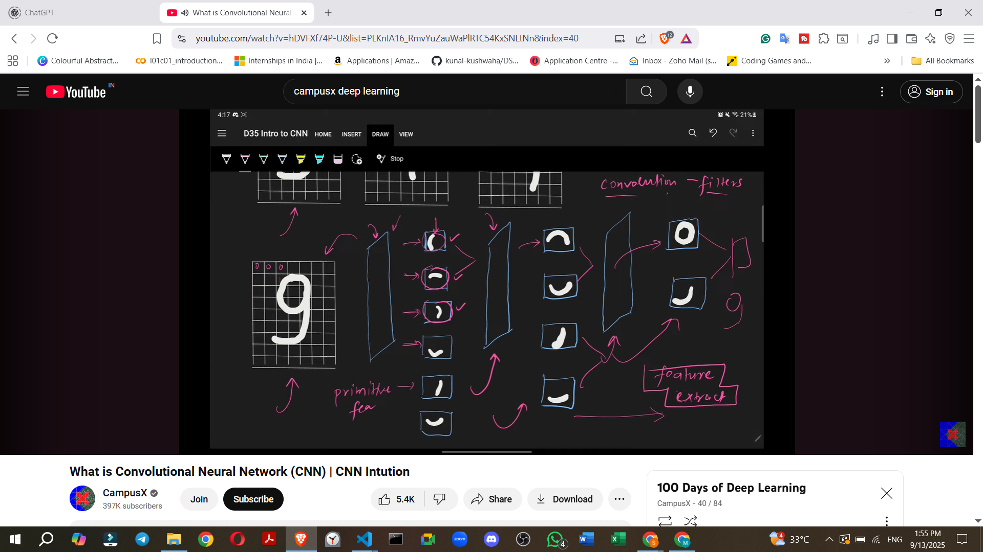

* + **Building Complex Features**:
    - The primitive features extracted by earlier layers are then passed to subsequent convolutional layers.
    - These deeper layers combine the simpler features to build more **complex and meaningful features**.
    - **Example (Digit 9)**: Edges are combined to form semi-circles, which are then combined to form a full circle. Simultaneously, other edges are combined to form lines.



* + - **Example (Cat Image)**: Initial layers might detect simple edges. Middle layers would combine these edges to form more complex parts like **ears, eyes, or a mouth**. The deepest layers would then combine these parts to recognize a **full face or body of a cat**, allowing the CNN to classify the image as a "cat".
  + **Deep Learning Principle**: As the CNN gets progressively "deeper" (more layers), it extracts increasingly abstract and complex features, moving from primitive edges to high-level conceptual components, ultimately leading to accurate classification.

### **7. Applications of CNNs**

CNNs are extremely popular and widely applied across a diverse range of problems:

* **Image Classification**: Categorizing a given image into one of several predefined classes.
  + **Example**: Determining if an image contains a **cat or a dog**, or identifying specific objects like a container ship, motor scooter, or leopard.

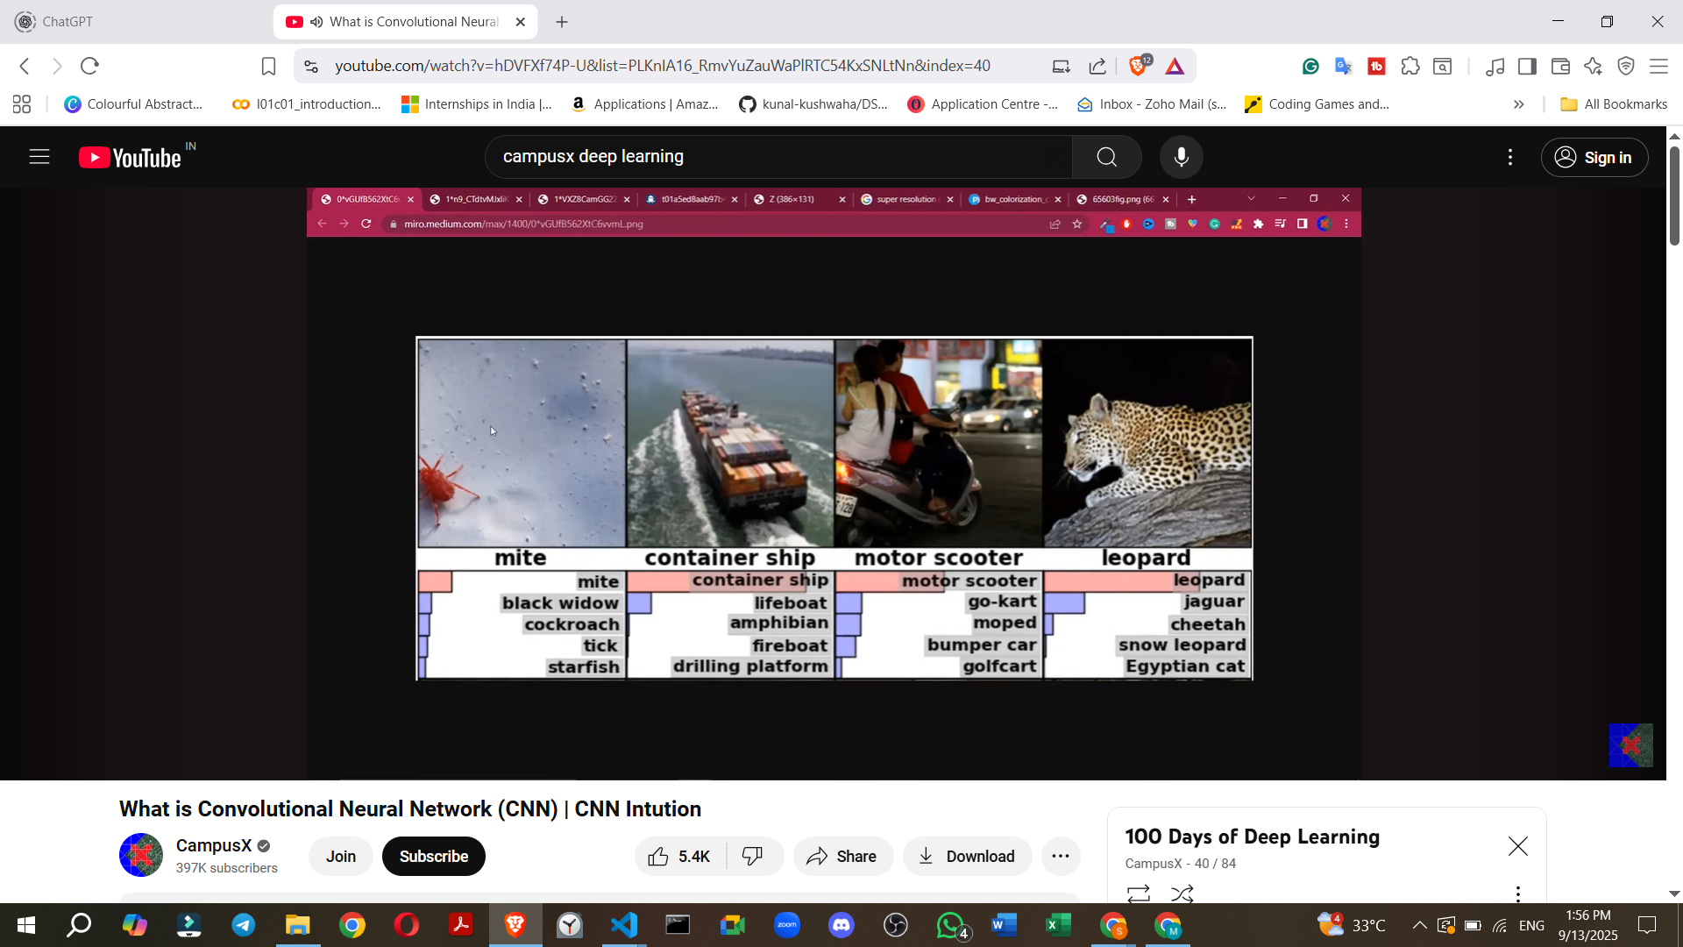

* **Object Localisation**: Identifying the presence and **exact location of a specific object** within an image by drawing a rectangular bounding box around it.

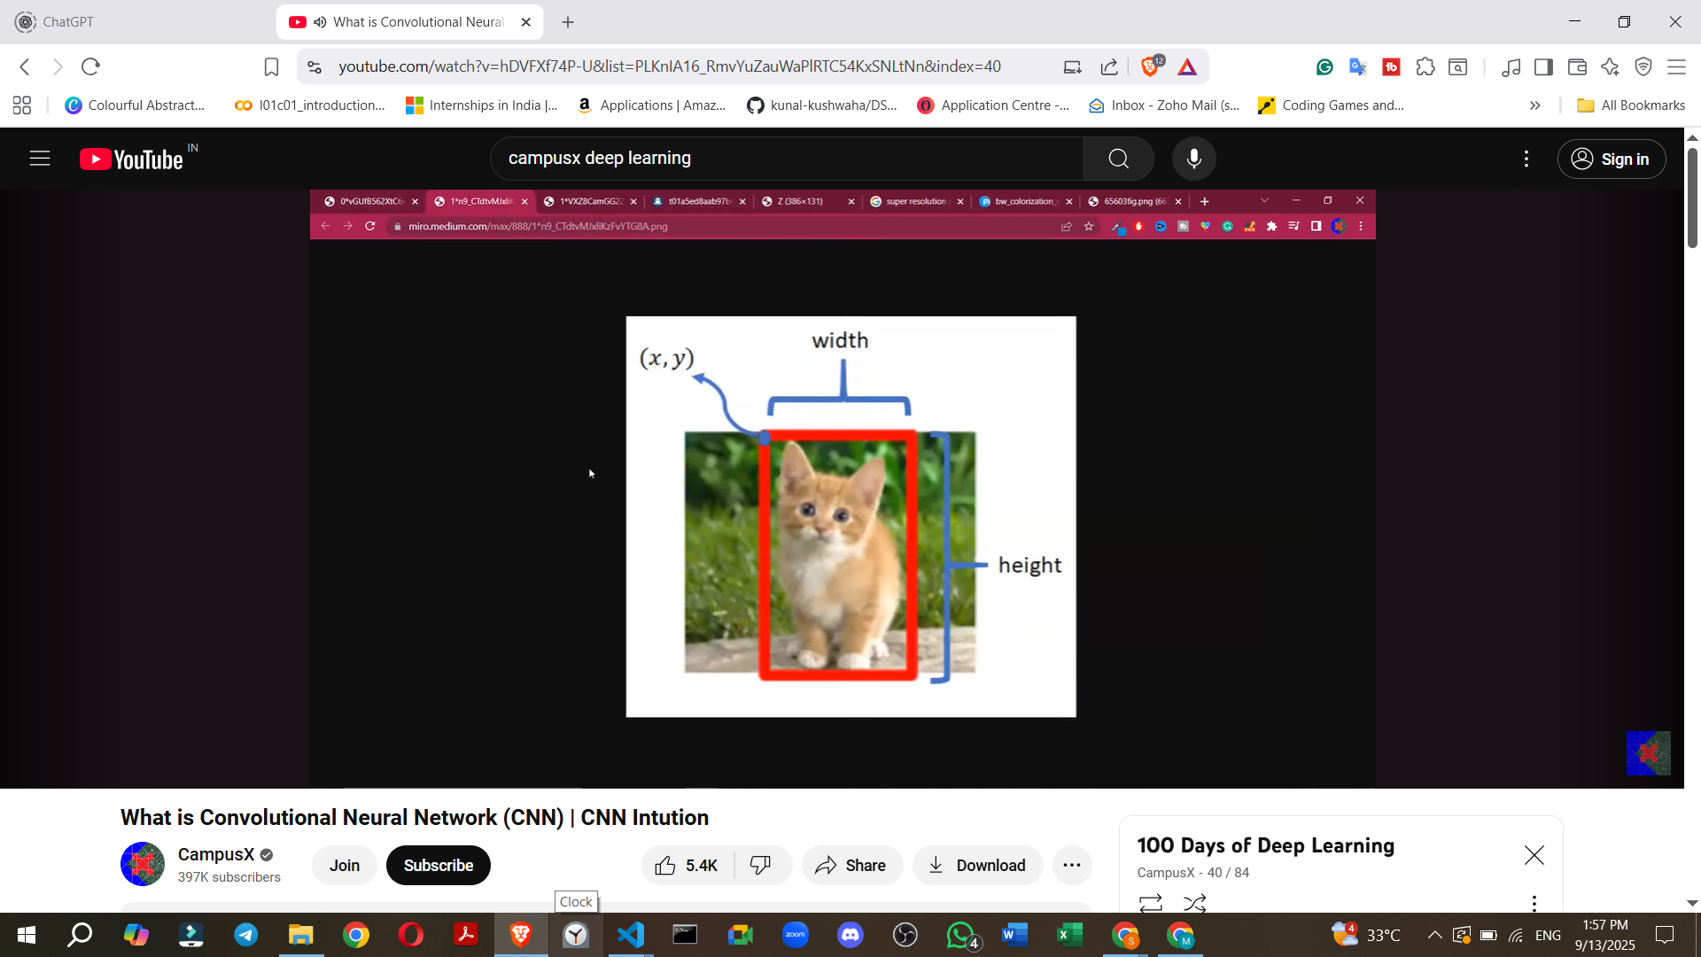

* **Object Detection**: A more complex task that involves identifying **all objects** within an image, locating them with bounding boxes, and also providing a **probability score** indicating the confidence of detection.
  + **Example**: Crucial for technologies like **self-driving cars** to detect pedestrians, other vehicles, and traffic signs.

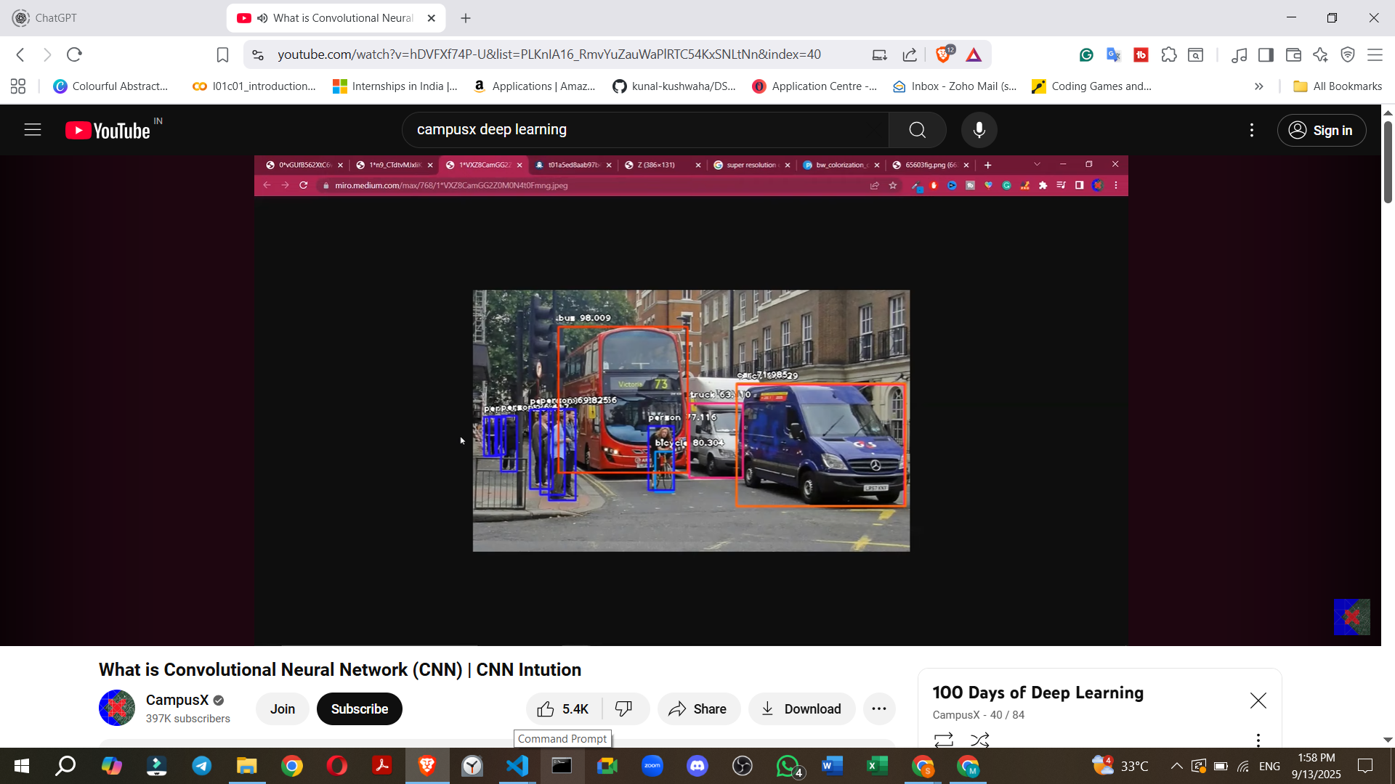

* **Face Detection and Recognition**:
  + **Example**: Used in modern **smartphone cameras** for unlocking devices or applying effects.

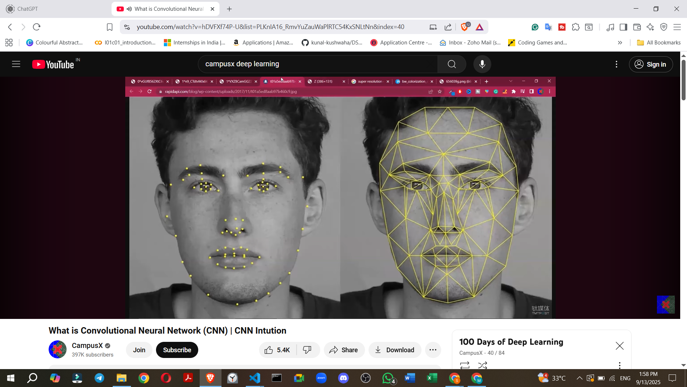

* **Image Segmentation**: Dividing an image into multiple segments or regions, often based on semantic meaning.
  + **Example**: Separating a **tiger from its background** in an image, useful for further image processing or analysis.

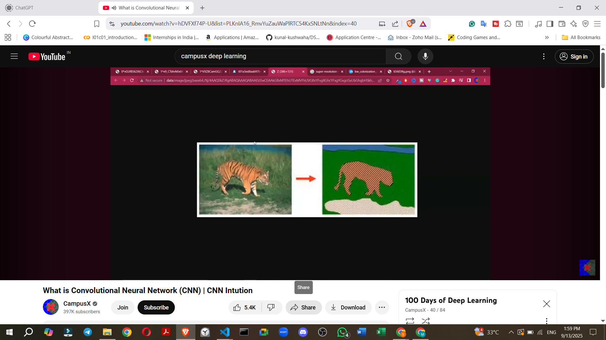

* **Super-Resolution**: Enhancing the quality and **increasing the resolution of low-resolution images**.

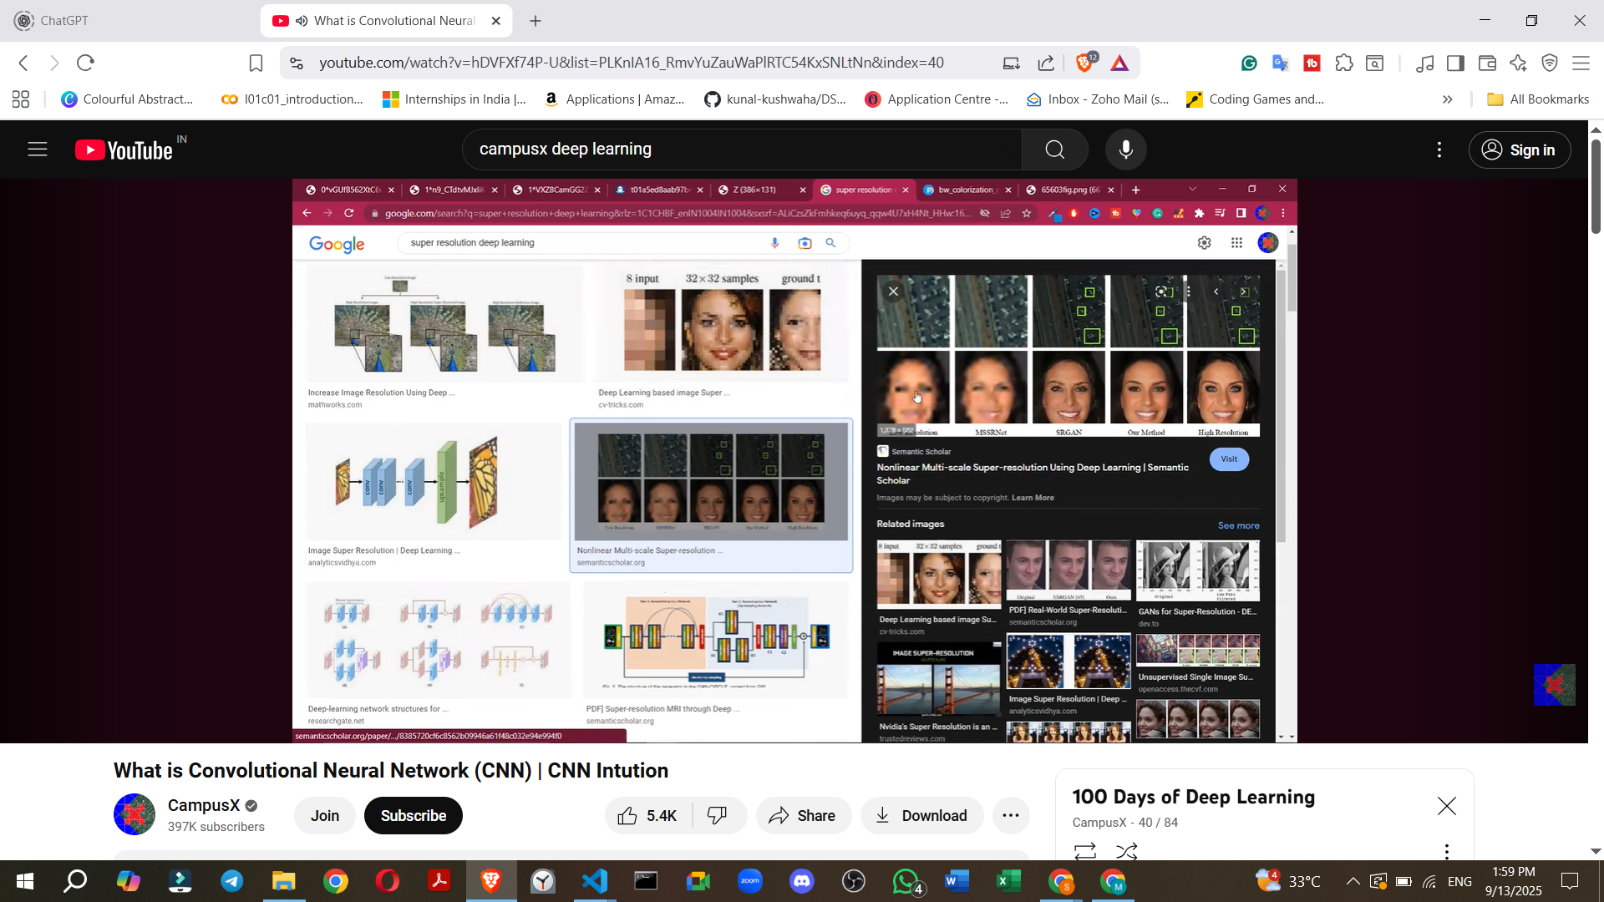

* **Image Colorisation**: Converting **black-and-white photos or videos into color**.
  + **Example**: Reviving old family photos or classic movies by adding color.

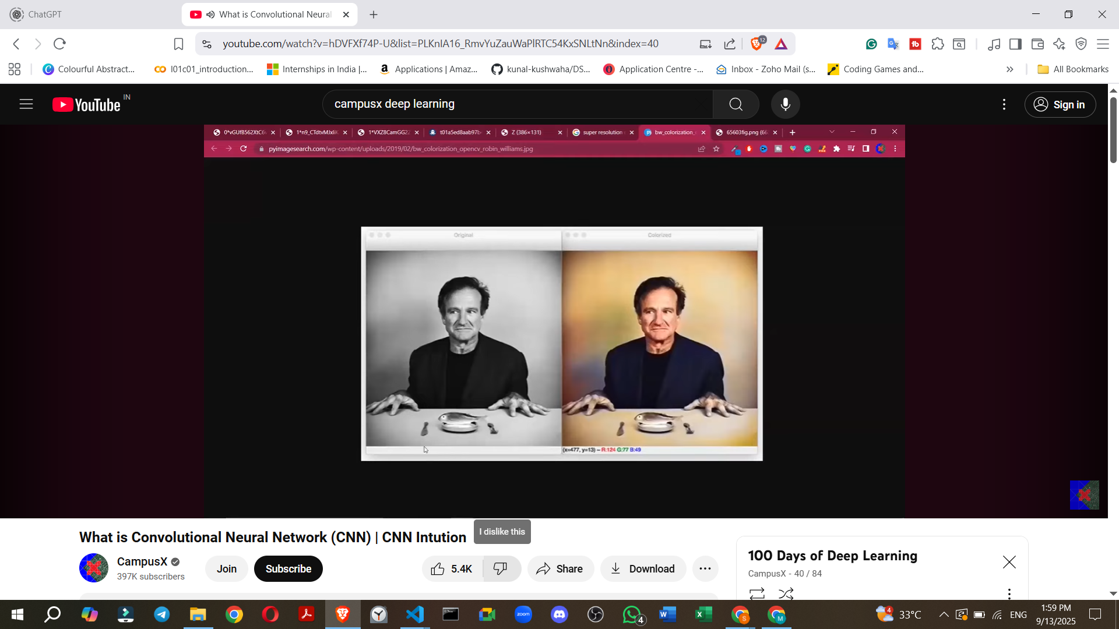

* **Pose Estimation**: Detecting the **current pose of a human body** from a camera feed.
  + **Example**: Used in fitness applications to track exercise movements (e.g., yoga poses) or in gaming consoles like **Microsoft Kinect or PlayStation** for interactive gameplay.

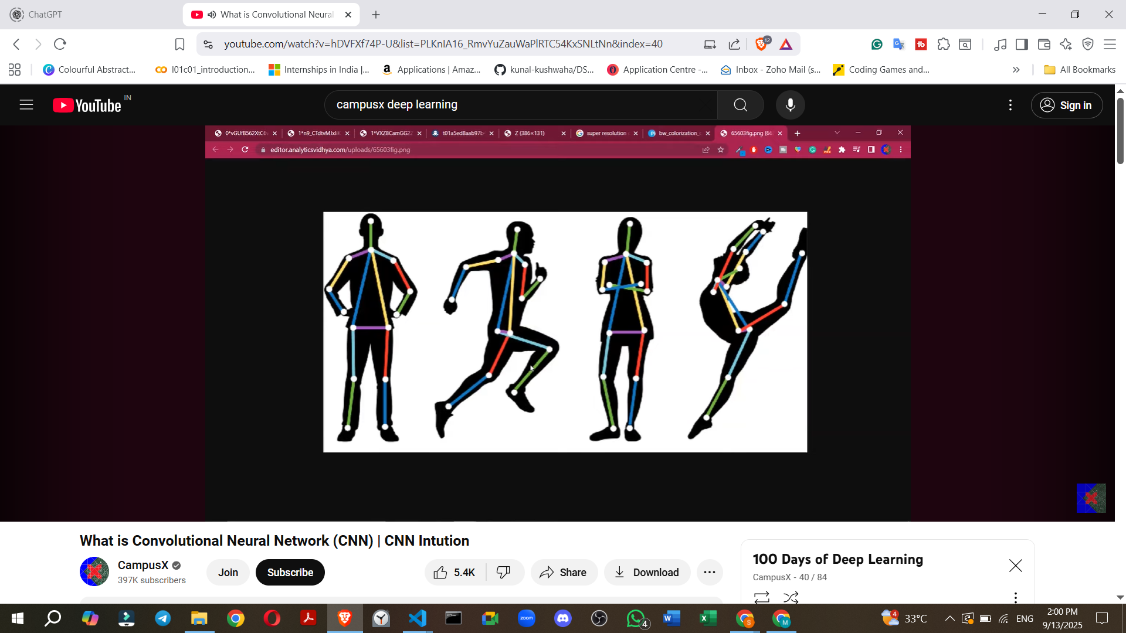

### **8. Speaker's Future Learning Plan for CNNs**

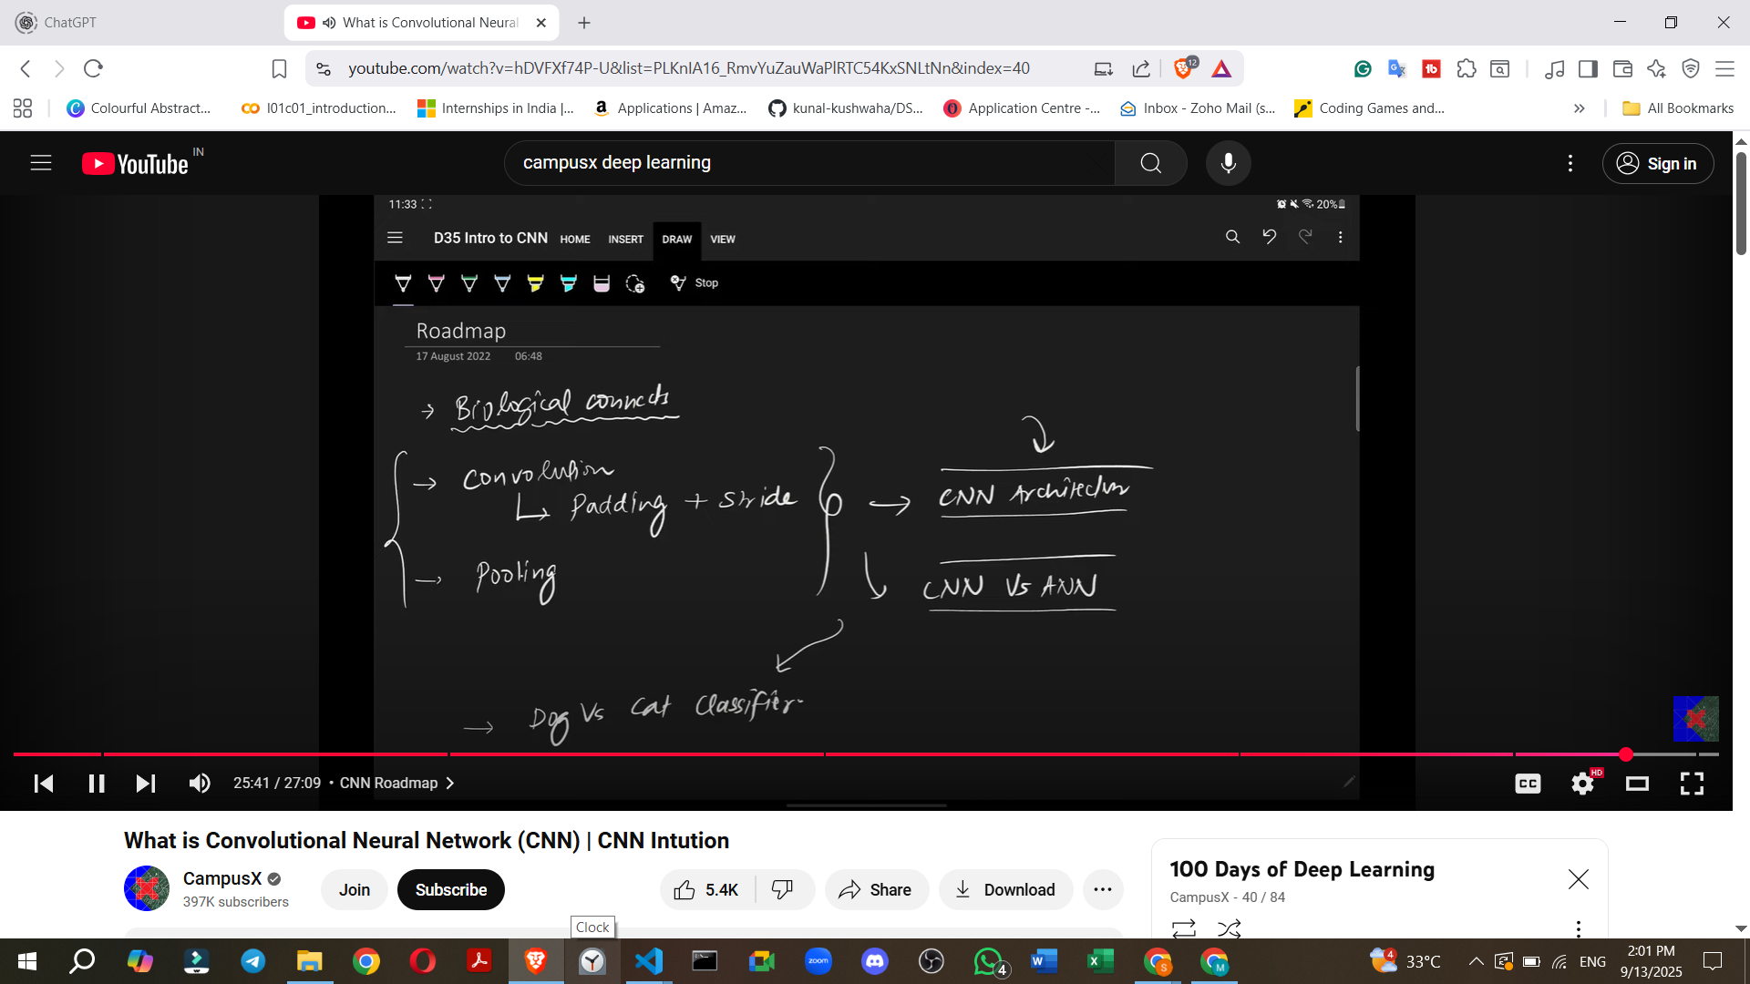

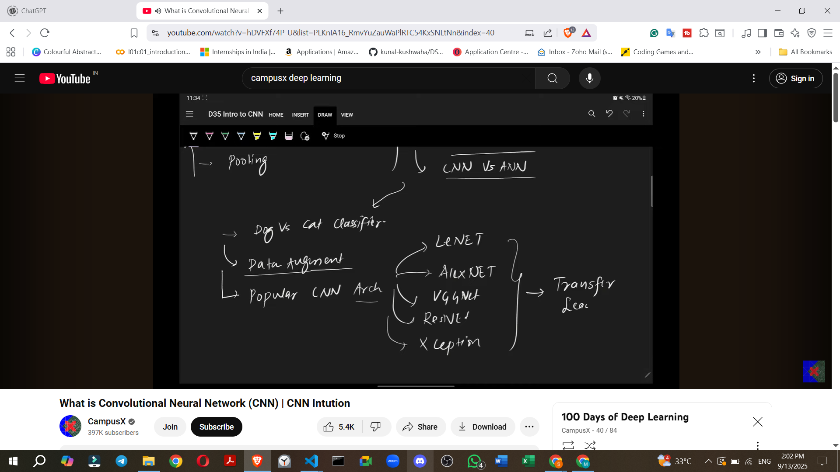

The speaker outlines a comprehensive plan for future videos to cover CNNs in detail:

* **Biological Connection**: A detailed exploration of how the human brain's visual system inspired CNN architecture.
* **Core CNN Concepts**:
  + **Convolution Operation**: In-depth explanation of how it works.
  + **Padding**: Understanding how padding is used in convolutional layers.
  + **Strides**: Detailed discussion on strides in convolution.
  + **Pooling Layer**: A thorough study of the pooling layer.
* **Building CNN Architectures**: How to construct a complete CNN model.
* **CNN vs. ANN Comparison**: Practical comparisons to highlight the performance differences.
* **Practical Implementation**:
  + Building a **"Dog vs. Cat Classifier"** using a real dataset of images.
  + **Data Augmentation**: A technique to expand datasets, especially useful when data is scarce.
* **Popular CNN Architectures**: Study of well-known and influential CNN models:
  + LeNet
  + AlexNet
  + VGGNet
  + ResNet
  + InceptionNet
* **Transfer Learning**: An important concept involving the use of pre-trained models.
* **Further Projects**: Object Detection will be covered after the speaker discusses Recurrent Neural Networks (RNNs).